**RasMol Assignment**

**Introduction to Bioinformatics**

**BTX-431**

**Submitted To : Submitted By :**

**Dr. Sumer Singh Meena Ankit Goyal**

**Assistant Professor Roll No. : 17103011**

**BioTech Department Branch : CSE Final year**

**Structure Analysis using ResMol**

* Insulin:

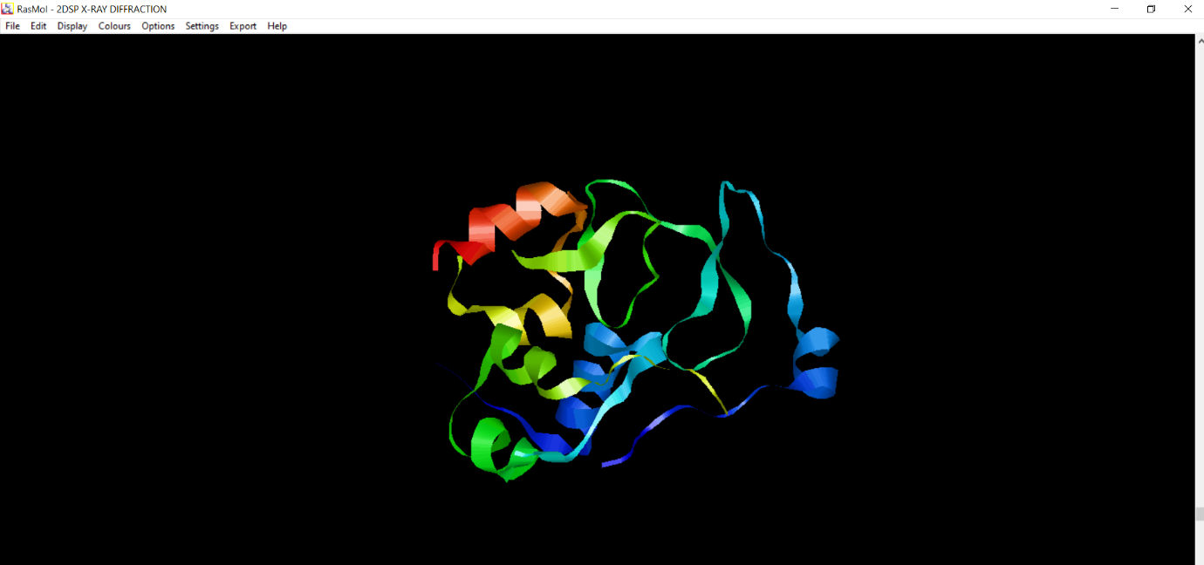

* 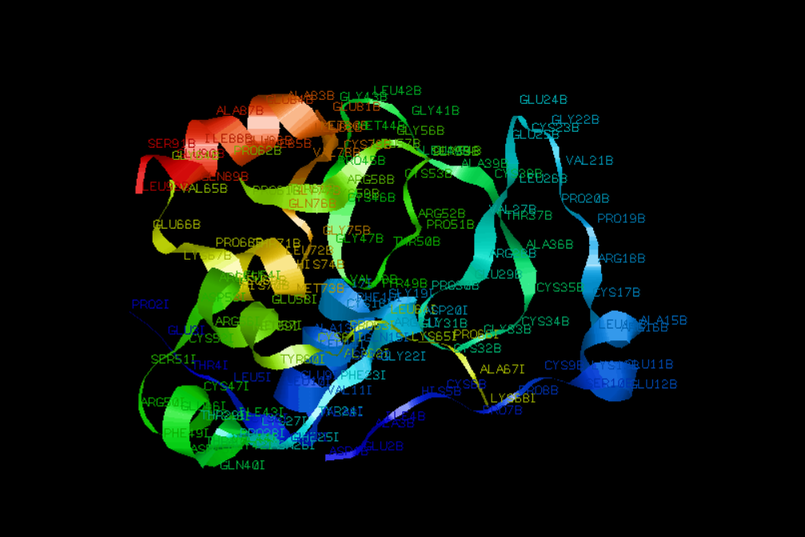Labels Mode:
* Ball and stick Form:

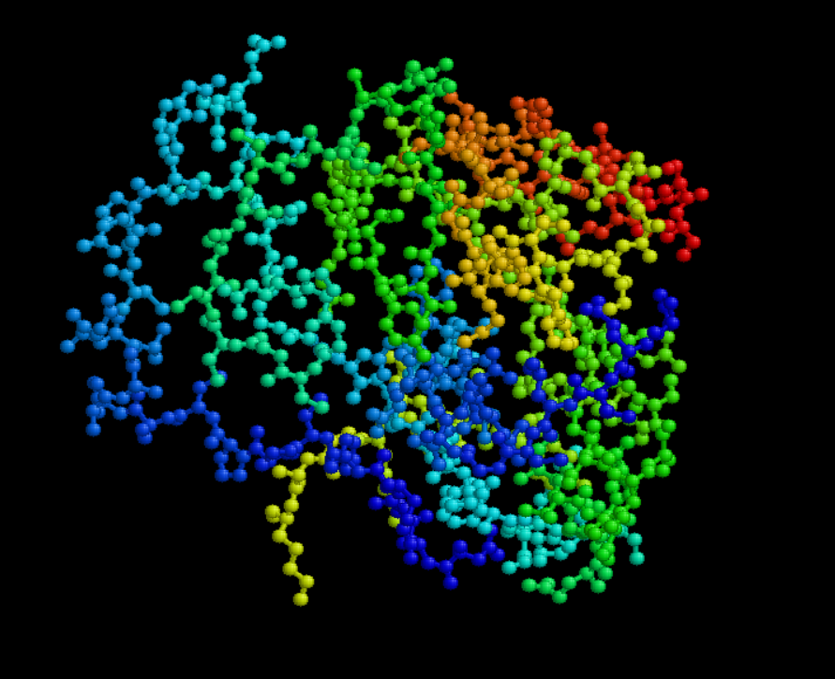

* Ball & Stick model with Labels in Slab Mode:

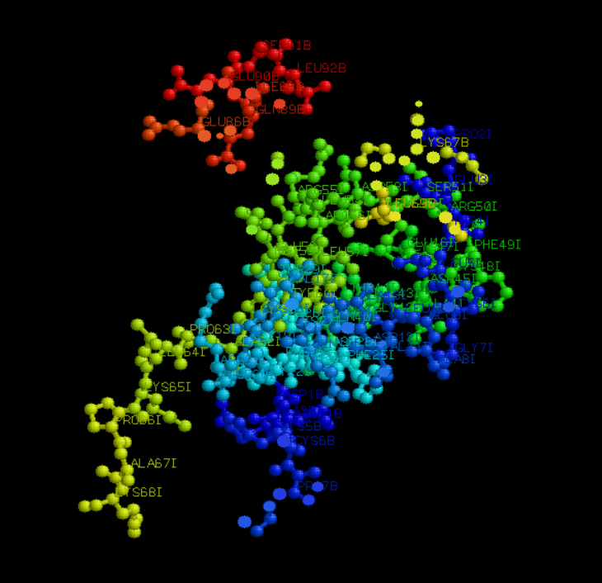

* 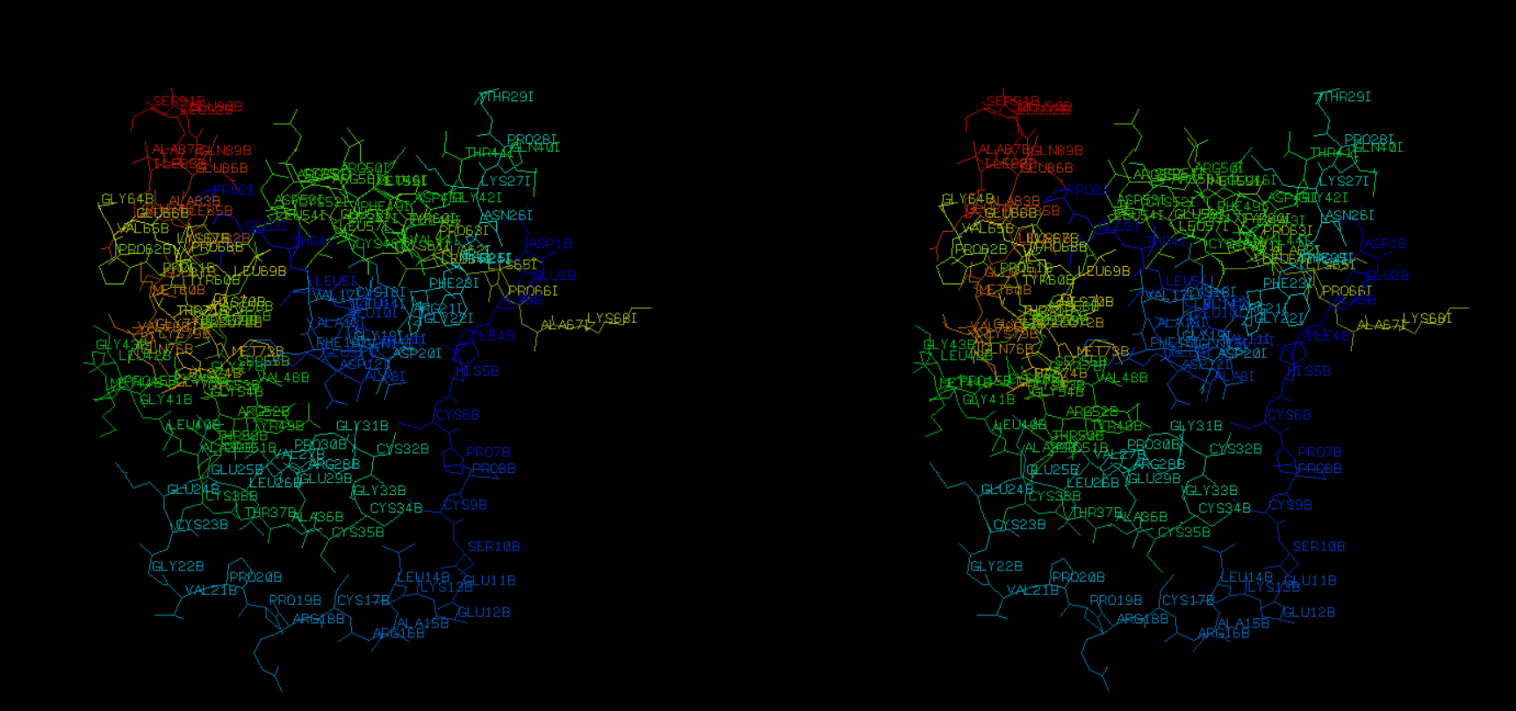Wireframe Model in Stereo Mode:

**Structure Analysis using PDB**

* 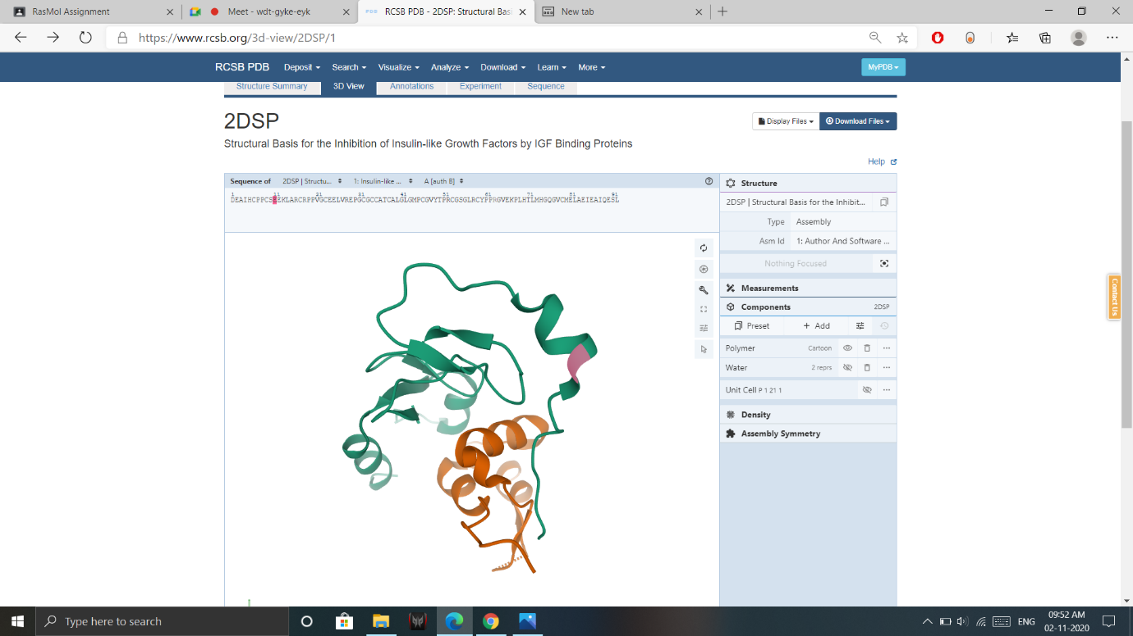Locating sequence Position in Protein structure:
* Spacefill Mode:

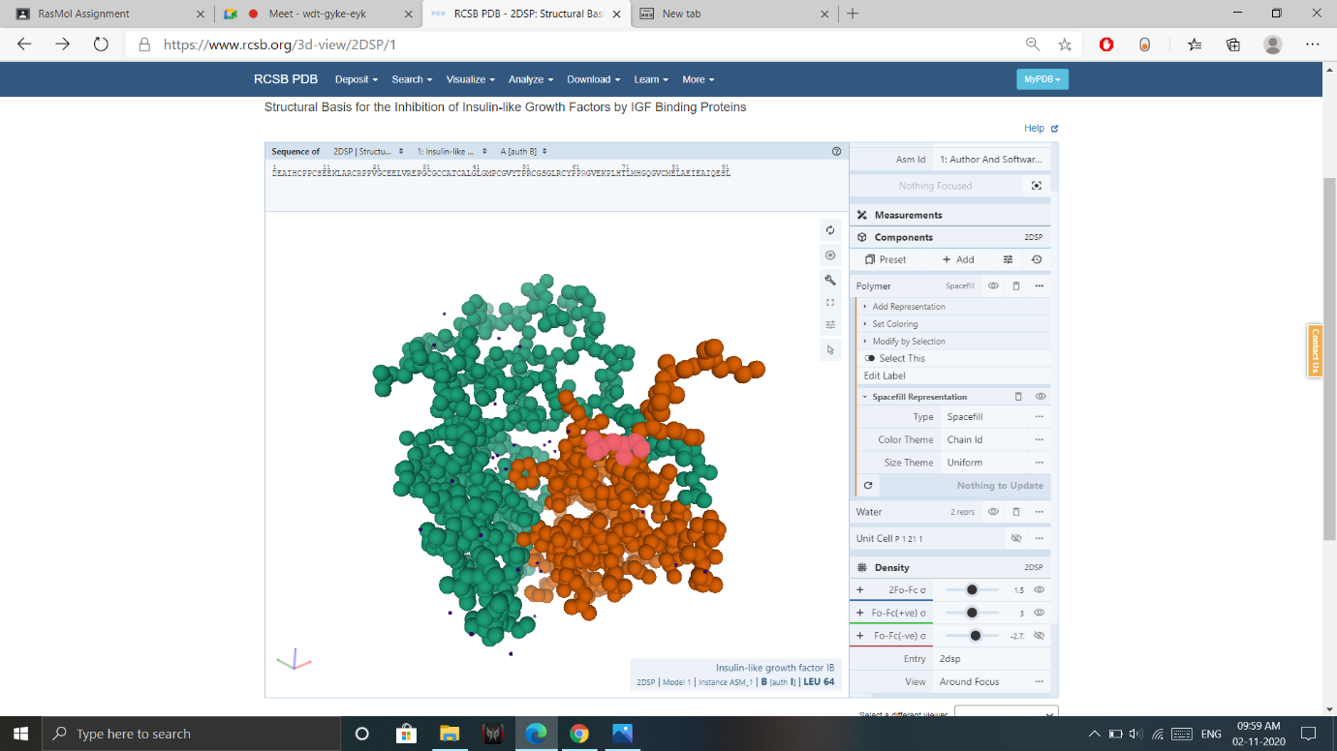

* 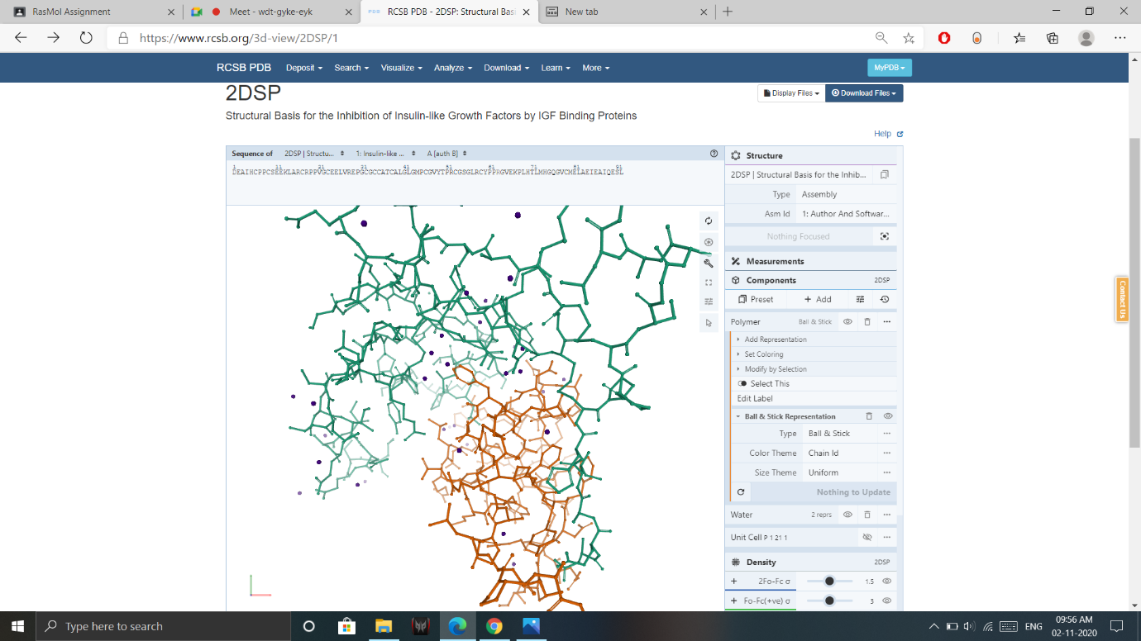Ball & Stick Representation:
* Adding New Components:

